IoT Projects User Manual

Three Complete IoT Solutions

1. EB and DG Status Monitor  
2. Fingerprint Access Control System  
3. RS485 Temperature & Humidity Monitor

# Initial Setup: Connecting to the SoftAP

Before accessing any of the three project portals, you must first establish a local connection to the device. This initial setup is common for all three projects and only needs to be done once.

**Step 1: Search for Wi-Fi Network**

Open the Wi-Fi settings on your smartphone, tablet, or PC. Look for the wireless network broadcast by the IoT controller like “**Accesscontrol#01**”, **TempMonitor#01**” etc.

**Step 2: Connect to the Network**

Select the network and connect to it. You may be prompted to enter a password “**12345678**” which is common for every device.

**Step 3: Access the Web Portal**

Once connected, launch any web browser (Chrome, Firefox, Safari, Edge, etc.) and navigate to the default IP address: **192.168.4.1**

**Step 4: Portal Loads Automatically**

The specific project management portal will load automatically based on the firmware installed on your device. You can now proceed to configure and monitor your IoT system.

**📌 Important Note:** *Ensure your device remains connected to the SoftAP network while accessing the portal. Some operating systems may automatically disconnect if they detect no internet connection. Disable "Auto-connect to better networks" temporarily if needed.*

# Project 1: EB and DG Status Monitor

This system provides real-time monitoring of power sources from both the Electricity Board (EB) and Diesel Generator (DG). It automatically detects power transitions, logs status changes, and sends SMS/voice call alerts to designated contacts. The system is ideal for critical infrastructure, data centers, hospitals, and industrial facilities where power monitoring is essential.

## Key Features:

* Dual power source monitoring (EB and DG)
* Configurable debounce filtering to eliminate false triggers
* Multi-contact alert system (SMS + Voice calls)
* Real-time status dashboard with signal strength monitoring
* Over-the-Air (OTA) firmware updates
* Remote system restart capability

## 1.1 GPIO Configuration Page

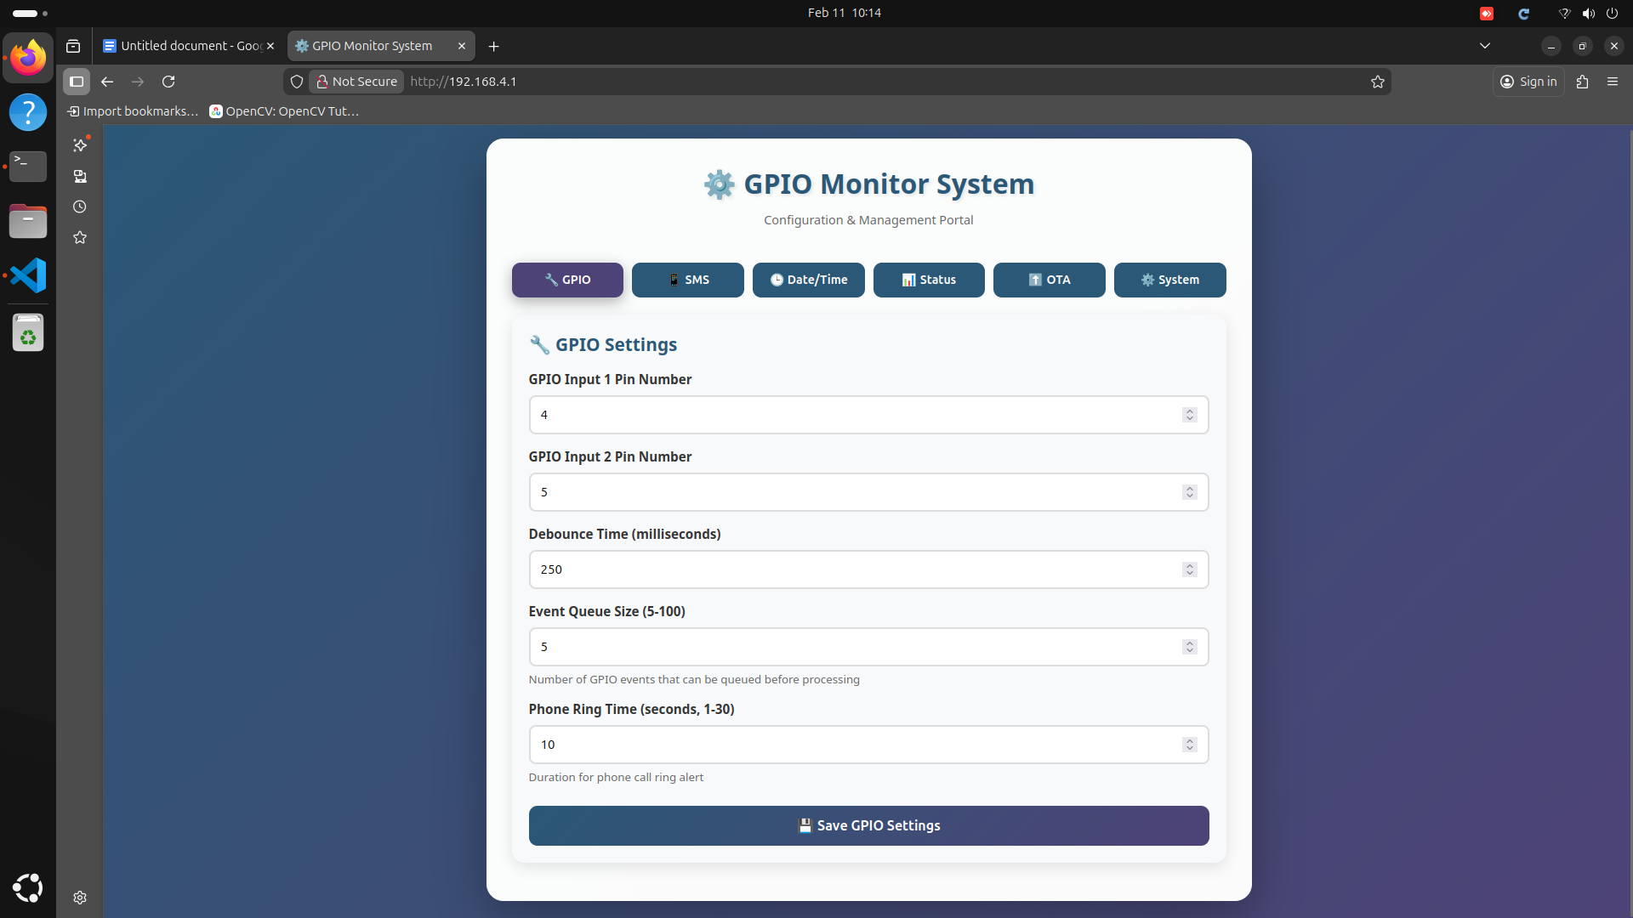

*Figure 1.1: GPIO Settings - Configure hardware pins for EB and DG monitoring*

This is the hardware configuration interface where you define which GPIO (General Purpose Input/Output) pins on the ESP32 controller are connected to the EB and DG status signals. This page will be accessed by admin only not others.

**Configuration Parameters:**

* **Debounce Time (ms):** Set the debounce delay in milliseconds (typically 50-200ms) to filter out electrical noise and prevent false triggers
* **Voice Call Duration:** Set how long the voice call should ring before timing out (default: 30 seconds)

## 1.2 SMS and Alert Configuration

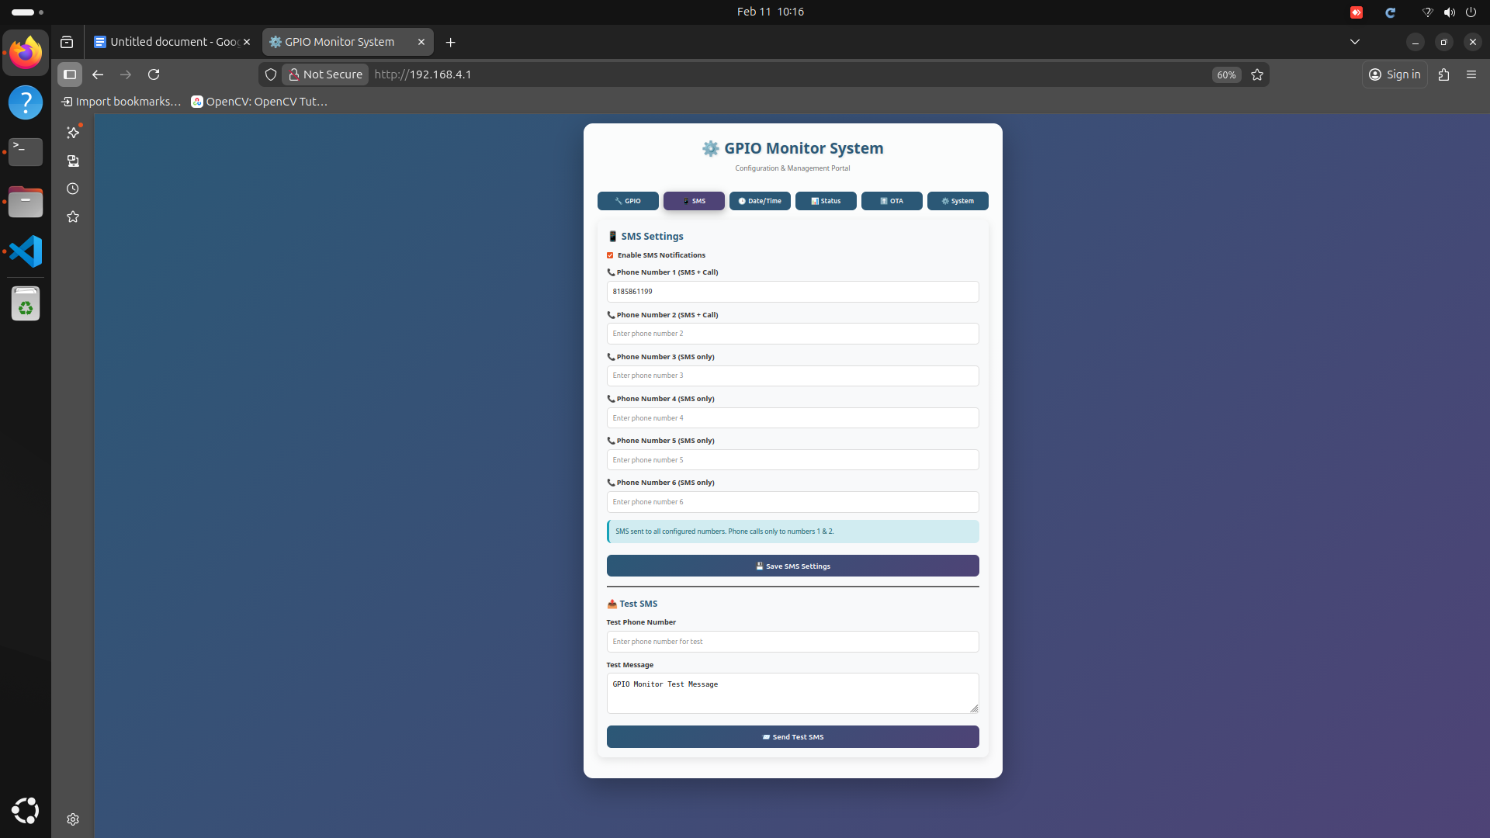*Figure 1.2: SMS Settings - Configure alert recipients and notification preferences*

Configure who receives alerts when power status changes occur. The system supports up to 6 phone numbers with different notification levels.

**Alert Configuration:**

* **Priority Contacts (1-2):** The first two phone numbers receive both SMS text alerts AND voice calls for critical notifications
* **Secondary Contacts (3-6):** These contacts receive SMS notifications only
* **Message Templates:** Customize the SMS message format with dynamic variables like {source}, {status}, {timestamp}

## 1.3 Date and Time Synchronization

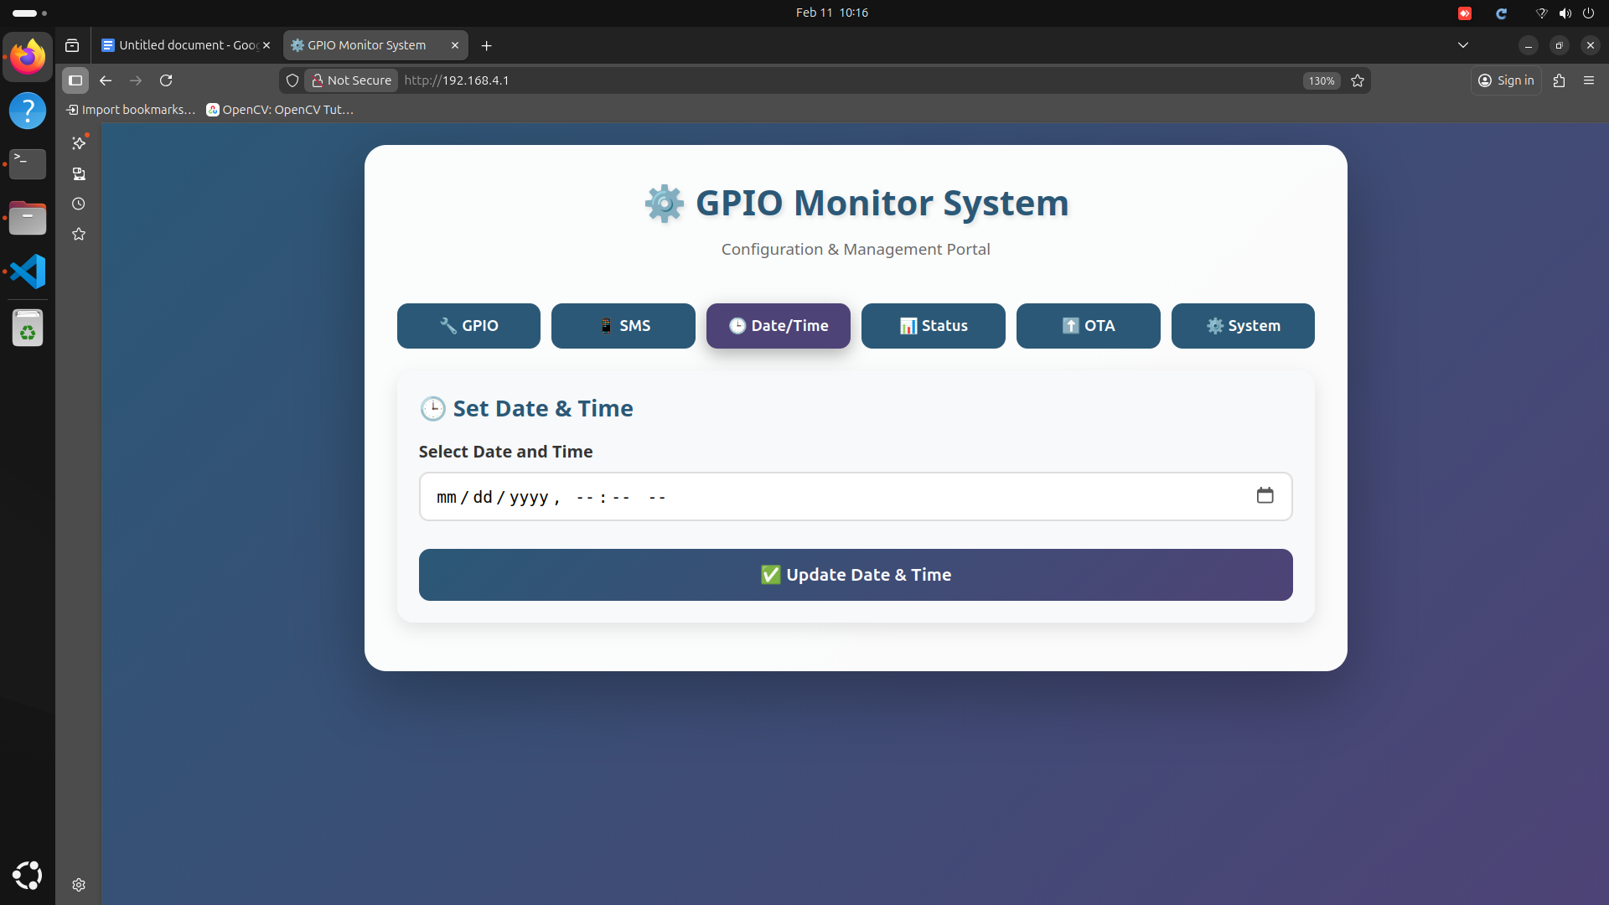

*Figure 1.3: Date/Time Settings - Synchronize the internal Real-Time Clock*

Accurate timekeeping is crucial for event logging and alert timestamping. This page allows you to synchronize the ESP32's internal Real-Time Clock (RTC) with the current date and time.

**Configuration Options:**

* **Manual Time Entry:** Enter the current date and time manually using the provided input fields
* **Time Zone Selection:** Choose your local time zone to ensure correct timestamp offsets
* **Date Format:** Select your preferred date display format (DD/MM/YYYY or MM/DD/YYYY)

## 1.4 System Status Dashboard

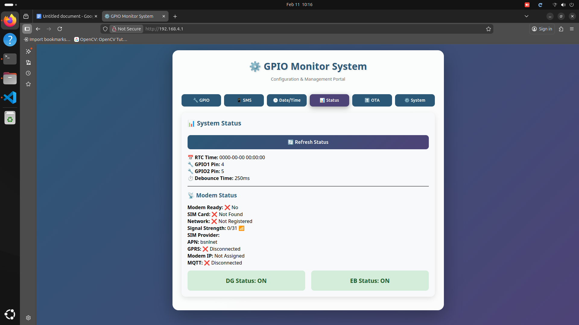

*Figure 1.4: System Status - Real-time diagnostic information and power source states*

The status dashboard provides a comprehensive real-time view of the entire system's operational state. This is your primary monitoring interface.

**Status Indicators:**

* **EB Status:** Shows current Electricity Board power state (ACTIVE/INACTIVE) with color coding (Green=Active, Red=Inactive)
* **DG Status:** Shows current Diesel Generator power state (ACTIVE/INACTIVE)
* **Modem Ready:** Indicates if the GSM/cellular modem is initialized and ready to send alerts
* **Signal Strength:** Displays cellular signal quality in dBm or signal bars (Excellent/Good/Fair/Poor)
* **Network Registration:** Shows if the modem is registered on the cellular network and can make calls/send SMS
* **Last Event:** Timestamp of the most recent power status change

## 1.5 Firmware Update (OTA)

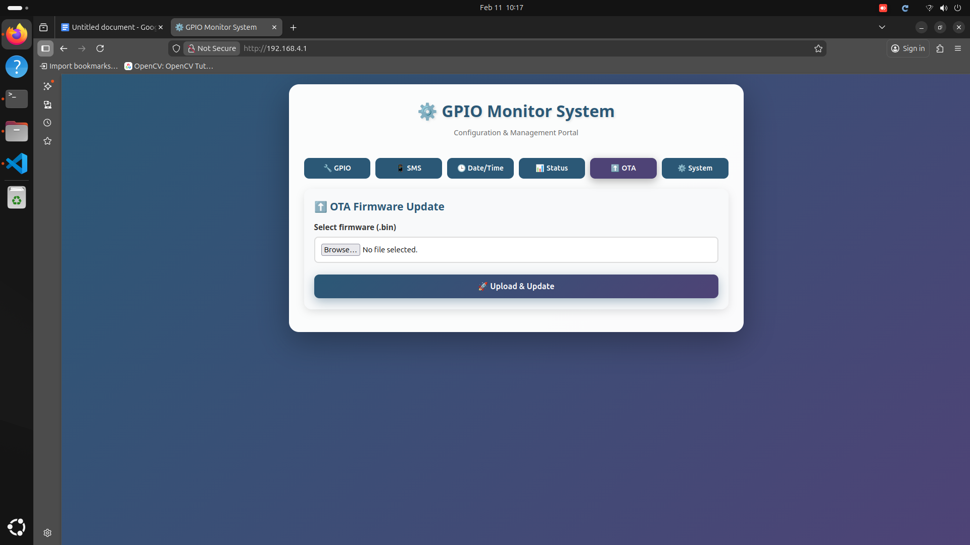

*Figure 1.5: OTA Update - Wireless firmware upgrade interface*

Over-The-Air (OTA) updates allow you to upgrade the ESP32 firmware remotely without physical access to the device. This is crucial for bug fixes, feature additions, and security patches. Here, file will be given by admin only if any other files uploaded, module will be crashed.

**Update Procedure:**

1. Obtain the latest firmware file (with .bin extension) from your system administrator or manufacturer
2. Click the "Choose File" or "Browse" button on the OTA page
3. Navigate to the .bin file location on your computer and select it
4. Click "Upload" or "Update Firmware" to begin the upload process
5. Wait for the upload to complete (typically 30-60 seconds) - DO NOT disconnect power or Wi-Fi
6. The device will automatically restart with the new firmware

**⚠️ Warning:** *Never disconnect power during firmware update. Upload only verified .bin files from trusted sources. Uploading corrupted firmware may brick the device.*

## 1.6 System Control and Restart

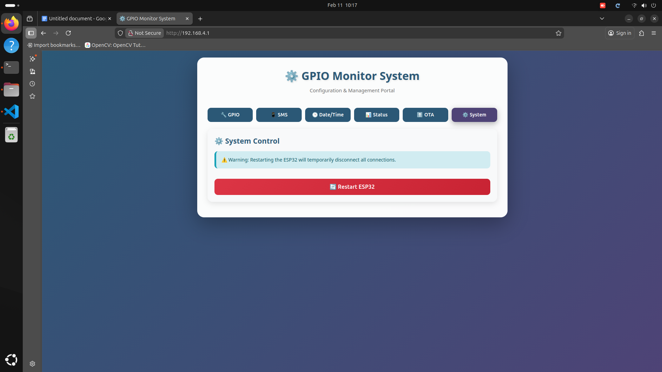

*Figure 1.6: System Control - Remote restart and maintenance options*

This page provides administrative control over the ESP32 hardware, primarily for maintenance and troubleshooting purposes.

**Control Functions:**

* **Restart ESP32:** Performs a soft reboot of the controller. Useful after changing configuration settings or to clear temporary errors
* **Clear Event Log:** Erases all stored power transition events (use with caution)

# Project 2: Fingerprint Access Control System

This biometric security solution provides fingerprint-based authentication for employee physical access control. The system uses a high-precision optical or capacitive fingerprint sensor to verify identities, control locks, and maintain detailed access logs with timestamp records.

## Key Features:

* Secure biometric authentication using fingerprint recognition
* Multi-user support with individual enrollment
* Real-time access logging with timestamps
* SMS/Call notifications for access events
* Relay control for electromagnetic locks
* User management with enrollment and deletion capabilities

## 2.1 Fingerprint Registration Interface

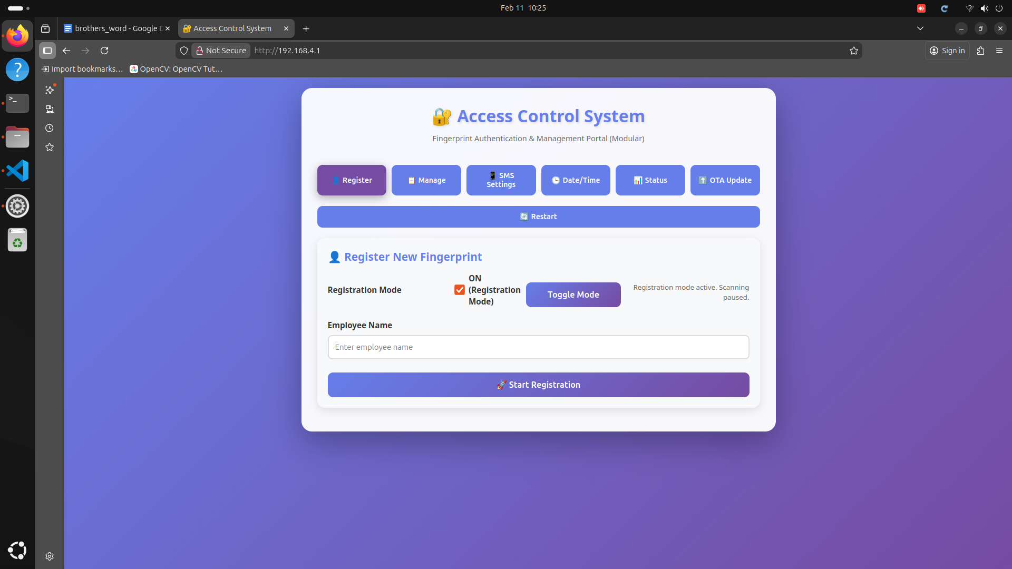

*Figure 2.1: Registration Page - Enroll new users into the biometric system*

This is the primary enrollment screen where new employees are added to the access control system. Each user must register their fingerprint before they can gain access.

**Enrollment Process:**

1. **Enter Employee Details:** Input the employee's full name in the designated text field
2. **Toggle Registration Mode ON:** Switch the "Registration Mode" toggle to the ON position. The system will enter fingerprint capture mode
3. **First Fingerprint Scan:** Instruct the employee to place their finger on the sensor. The LED will typically blink to indicate scanning
4. **Remove and Re-place Finger:** Ask the employee to lift their finger and place it again for verification (usually 2-3 scans required)
5. **Confirmation:** Once successful, the system will display "Registration Successful" and assign a unique ID to the user
6. **Toggle Registration Mode OFF:** Disable registration mode to return the system to normal access control operation

**💡 Tip:** *For best results, ensure fingers are clean and dry. Scan the same finger multiple times for improved accuracy. Consider registering both the index and middle finger of the dominant hand as backup.*

## 2.2 User Management Dashboard

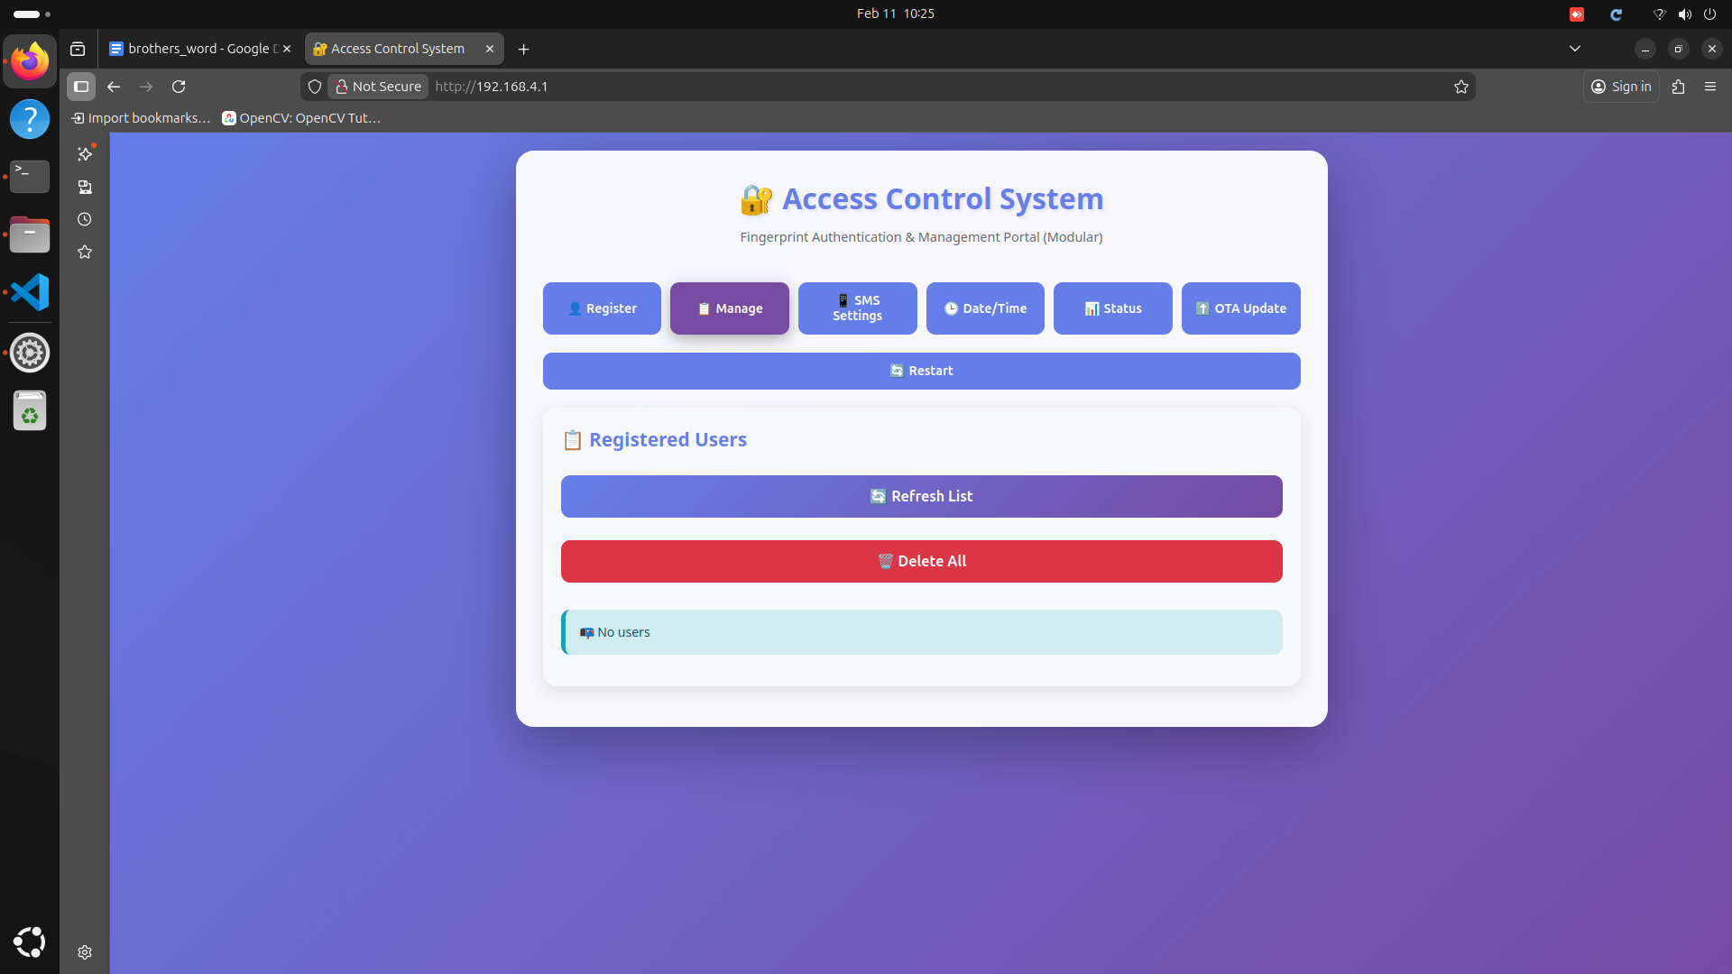

*Figure 2.2: User Management - View and manage all enrolled fingerprints*

This page displays a comprehensive list of all users enrolled in the biometric database. Administrators can view, refresh, and manage user records from this interface.

**Management Functions:**

* **User List Display:** Shows all enrolled users with their ID number, name, enrollment date, and last access timestamp
* **Refresh List:** Reloads the user database from the fingerprint sensor's internal memory
* **Delete Individual User:** Click the delete icon next to a specific user to remove them from the system
* **Delete All:** Completely wipes the biometric database - use with extreme caution (requires confirmation)

## 2.3 Access Alert Configuration

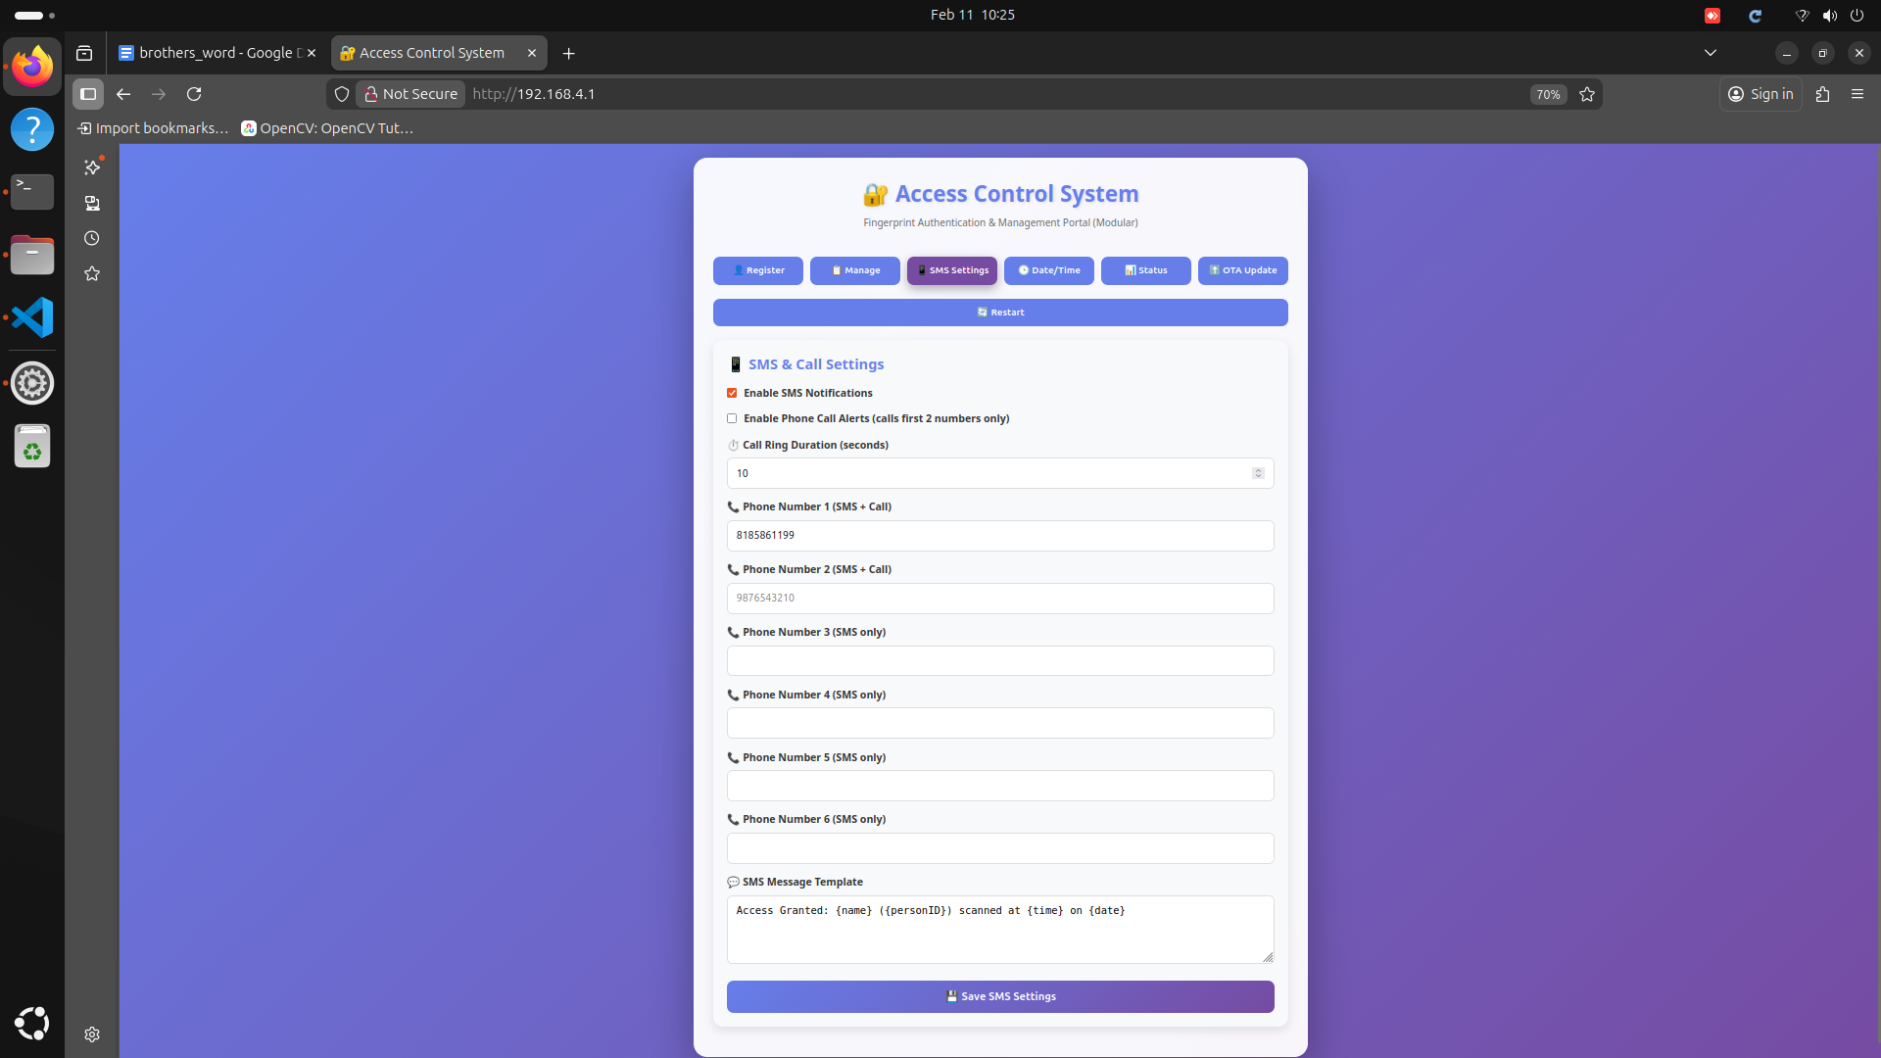

*Figure 2.3: SMS & Call Settings - Configure access event notifications*

Configure automated notifications that are sent when access events occur. This is particularly useful for monitoring after-hours access, security alerts.

**Notification Settings:**

* **SMS Template Customization:** Define the message format using dynamic variables like {name}, {time}, {status}. Example: "Access Granted: {name} at {time}"
* **Recipient Phone Numbers:** Add up to 6 phone numbers that will receive SMS notifications for access events
* **Voice Call Settings:** Configure if unauthorized access attempts should trigger voice calls
* **Call Ring Duration:** Set how long the phone should ring before the call times out (10-60 seconds)
* **Event Filters:** Choose which events trigger notifications (successful access, failed attempts, specific users, time-based rules)

## 2.4 Time Synchronization for Access Logs

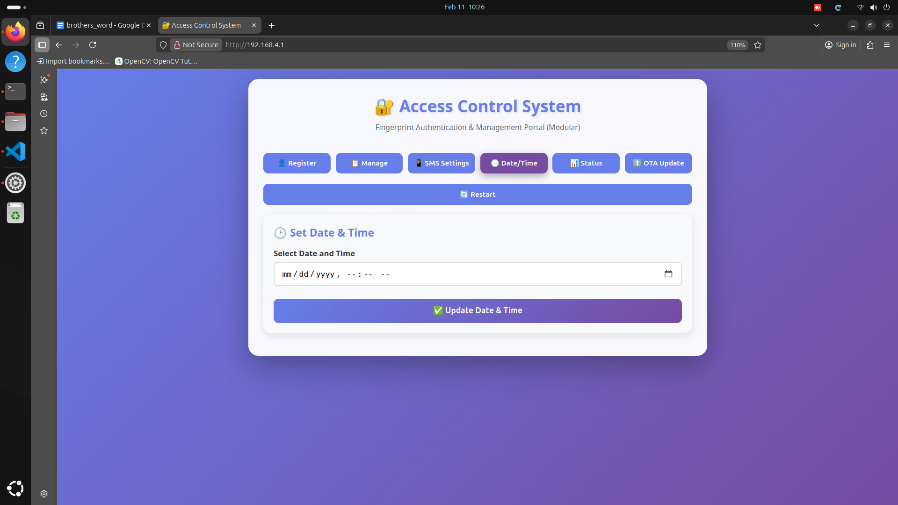

*Figure 2.4: Date/Time Settings - Ensure accurate timestamp logging*

Accurate timekeeping is critical for access control systems, both for legal compliance and attendance tracking. This page allows you to set the correct date and time for the controller.

**Time Configuration:**

* **Current System Time:** Displays the current time as stored in the RTC (Real-Time Clock)
* **Manual Adjustment:** Manually set the date and time using the calendar and time picker interfaces
* **Time Zone Selection:** Select your geographical time zone to ensure correct local time display

## 2.5 System Status and Sensor Health

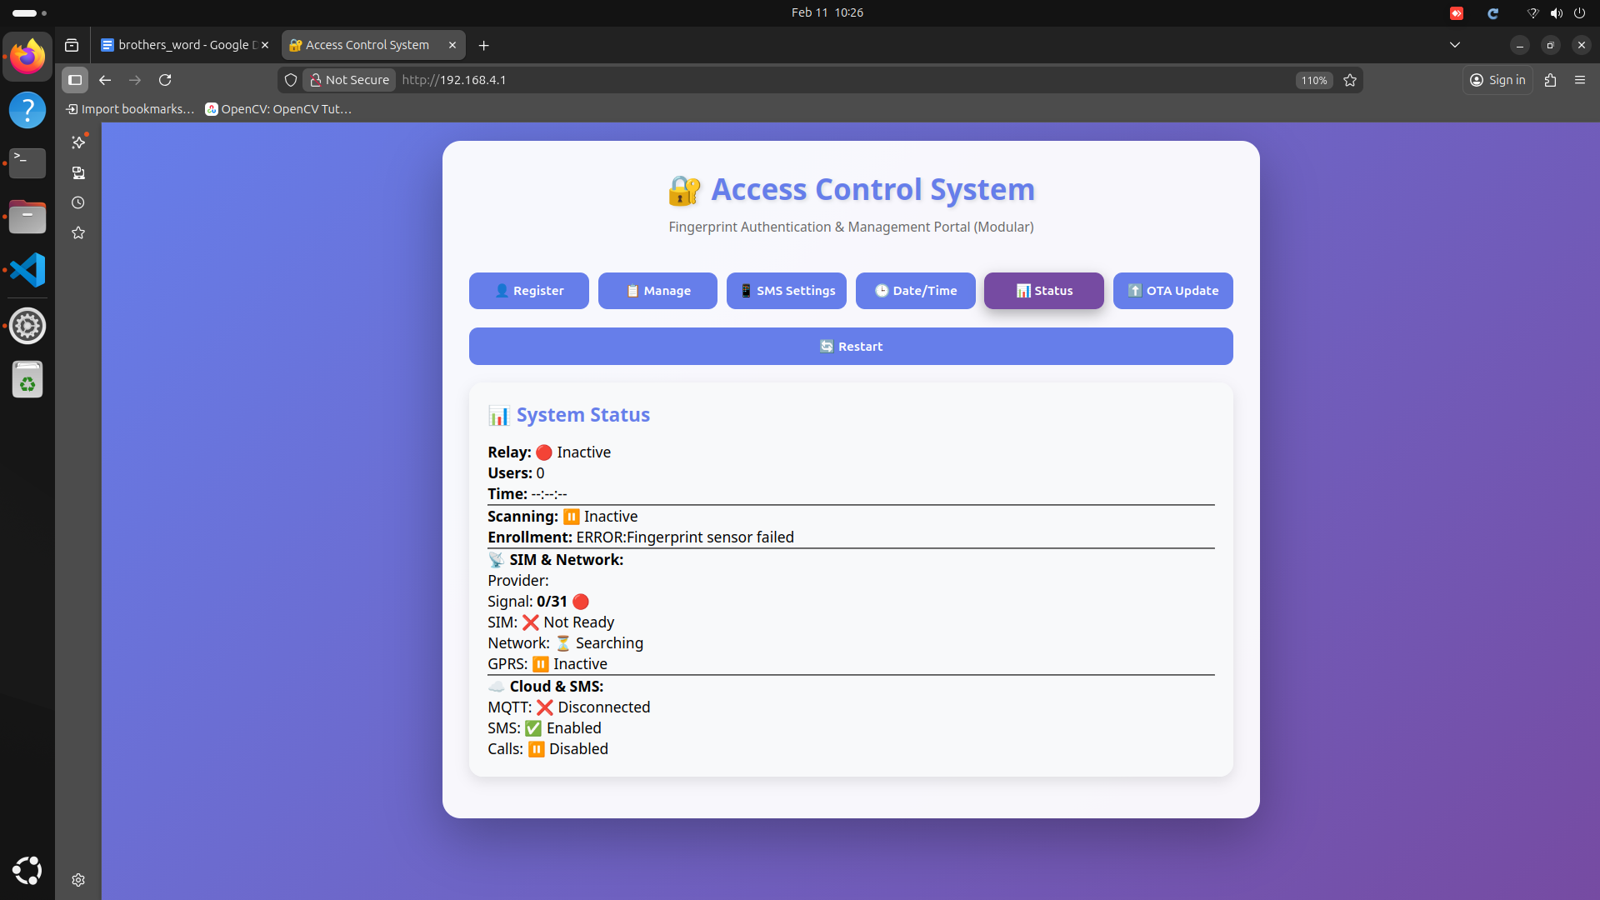

*Figure 2.5: Status Page - Monitor biometric sensor and relay operation*

The status page provides real-time diagnostic information about the fingerprint sensor, door lock relay, and overall system health.

**Status Indicators:**

* **Sensor Status:** Indicates if the fingerprint sensor is connected and operational (READY/ERROR/NOT DETECTED)
* **Total Enrolled Users:** Shows how many fingerprints are currently stored in the sensor's memory (e.g., "4 / 20")
* **Relay Status:** Displays current state of the door lock control relay (ACTIVE = unlocked, INACTIVE = locked)
* **Last Access Event:** Shows details of the most recent fingerprint scan - user name, result (success/fail), and timestamp
* **Sensor Temperature:** Internal sensor temperature reading (for diagnostic purposes)
* **Communication Status:** Indicates if the ESP32 can communicate with the fingerprint module (connection status)

## 2.6 Firmware Updates (OTA)

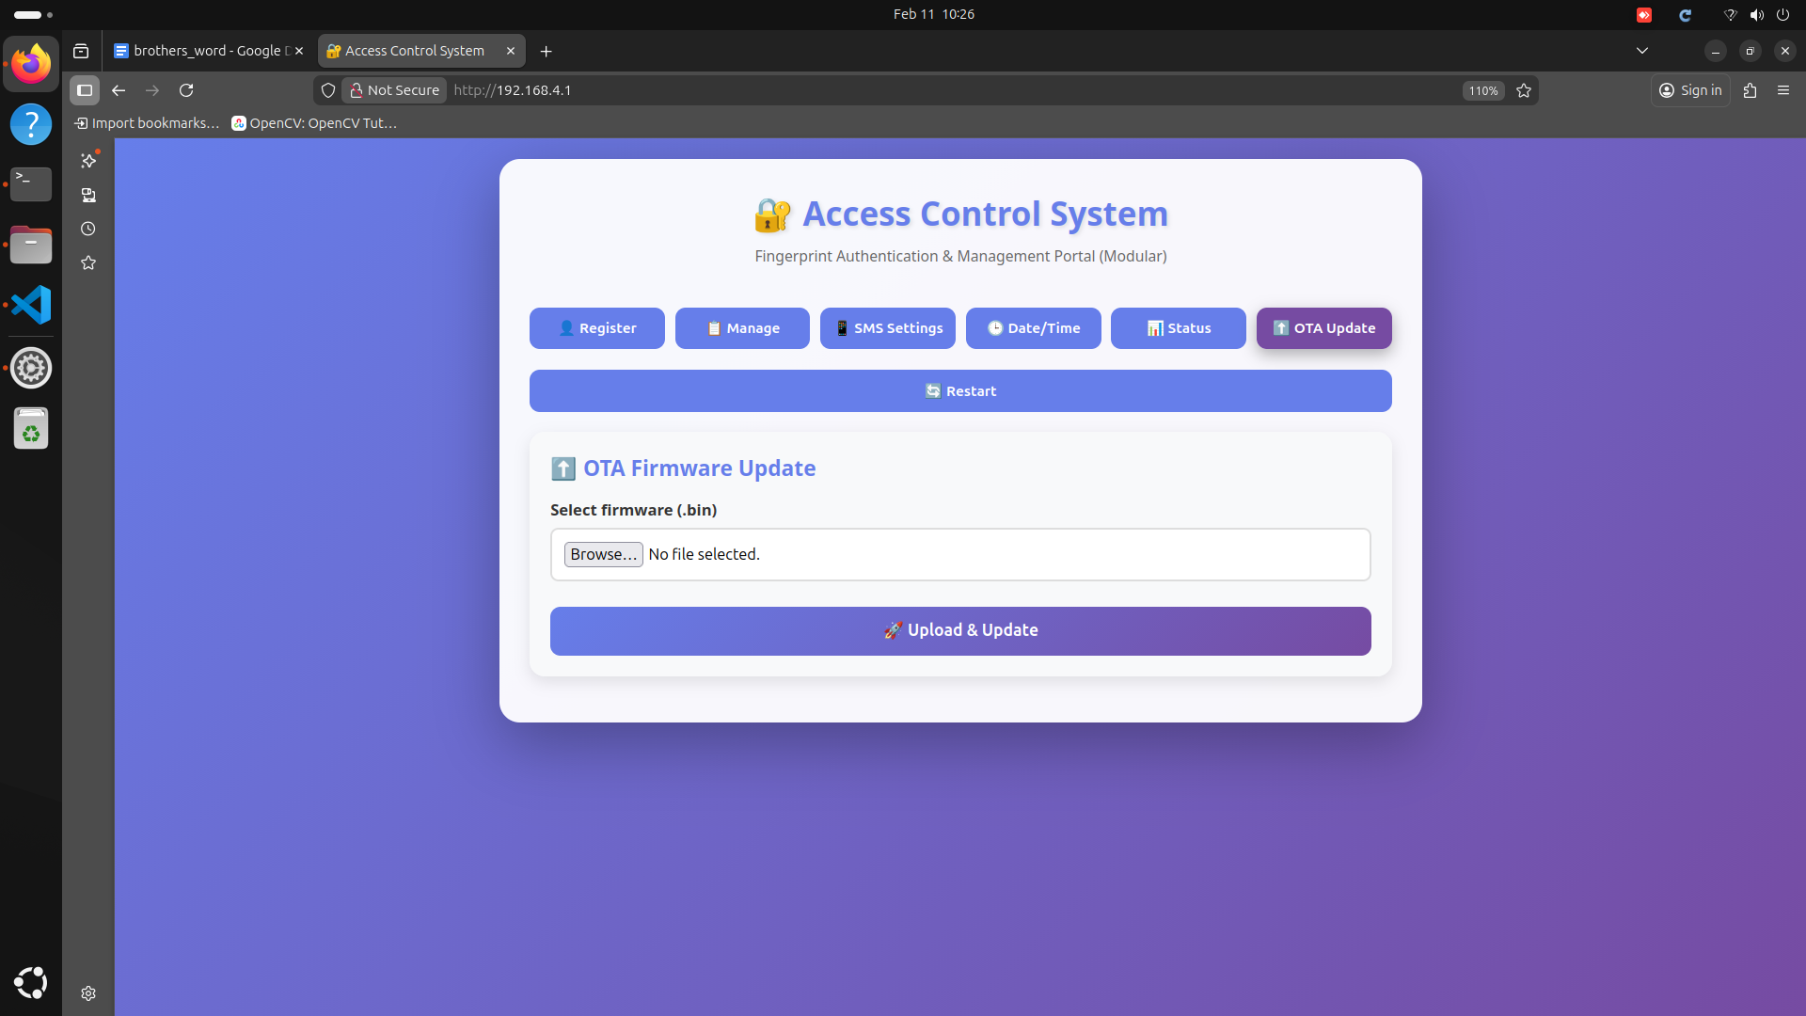

*Figure 2.6: OTA Update - Wireless firmware upgrade for access control system*

This page allows you to update the fingerprint controller firmware without physical access to the device. Updates may include new features, security patches, or improvements to fingerprint matching algorithms.

**Update Guidelines:**

* **Firmware Source:** Only use firmware files (.bin) provided by the manufacturer or system administrator
* **Version Check:** Verify current firmware version on the status page before updating
* **Upload Process:** Select the .bin file, click Upload, and wait for completion (30-90 seconds)
* **Post-Update Verification:** After automatic restart, verify sensor connectivity and test with a known fingerprint

# Project 3: RS485 Temperature & Humidity Monitor

This industrial-grade environmental monitoring system uses the Modbus RTU protocol over RS485 communication to continuously track temperature and humidity levels. The system supports threshold-based alerts, periodic data logging, and is ideal for server rooms, warehouses, greenhouses, laboratories, and manufacturing facilities.

## Key Features:

* Industrial RS485 Modbus RTU communication protocol
* Configurable high/low temperature and humidity thresholds
* Periodic sensor polling with adjustable intervals
* Automatic SMS/call alerts when thresholds are exceeded
* Real-time environmental data display
* Historical data logging and trend analysis

## 3.1 Modbus and Threshold Configuration

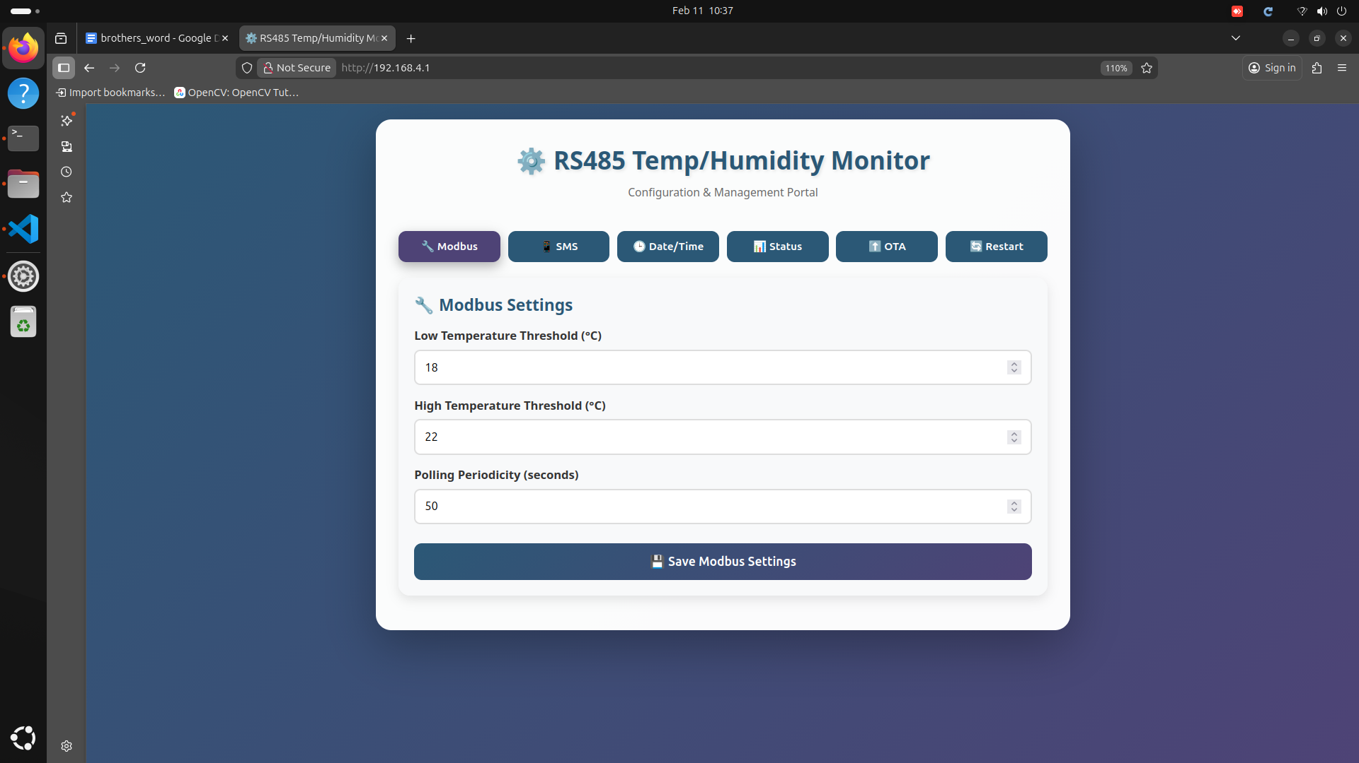

*Figure 3.1: Modbus Settings - Configure sensor parameters and operational thresholds*

This is the primary configuration page where you define acceptable environmental ranges and sensor polling behavior. The system will automatically alert you when readings fall outside these ranges.

**Configuration Parameters:**

* **High Temperature Limit (°C):** Set the maximum acceptable temperature. Readings above this will trigger an alert (e.g., 35°C for a server room)
* **Low Temperature Limit (°C):** Set the minimum acceptable temperature. Readings below this will trigger an alert (e.g., 15°C)
* **Polling Periodicity (seconds):** How often the system reads the sensor via Modbus (typical values: 60-300 seconds). Lower values = more frequent monitoring but higher power consumption

## 3.2 Alert Configuration and Network Information

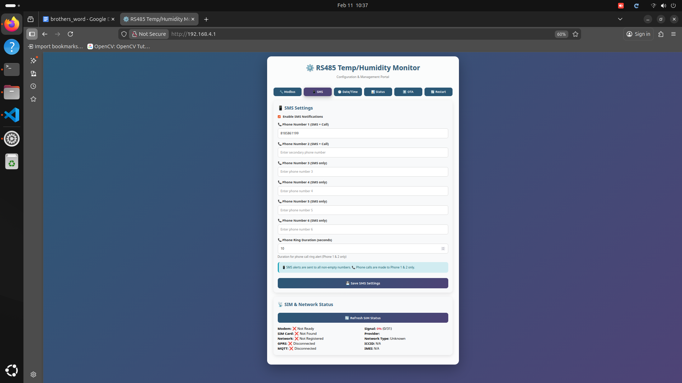

*Figure 3.2: SMS & Network Settings - Configure contacts and view modem details*

This page combines alert contact management with network diagnostic information. Configure who receives threshold alerts and monitor the cellular modem's connection status.

**Alert Settings:**

* **Contact Numbers:** Enter up to 6 phone numbers to receive SMS alerts when temperature or humidity thresholds are breached
* **Message Templates:** Customize alert messages with variables like {temperature}, {humidity}, {status}, {timestamp}
* **Alert Escalation:** Configure if multiple alerts should be sent at increasing intervals if the condition persists

**Network Diagnostics:**

* **ICCID:** Integrated Circuit Card Identifier - unique serial number of the SIM card inserted in the modem
* **Network Operator:** Name of the cellular network the modem is currently registered to
* **Signal Quality:** Cellular signal strength indicator (measured in dBm or CSQ scale)

## 3.3 Date and Time Synchronization

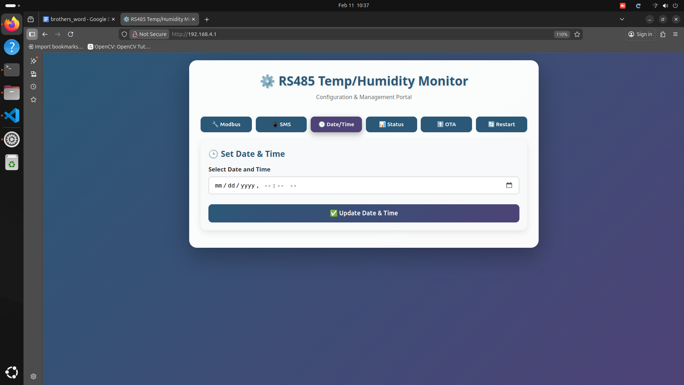

*Figure 3.3: Date/Time Settings - Set system clock for accurate data logging*

Accurate timestamps are essential for environmental monitoring to correlate readings with specific events or time periods. This page allows you to synchronize the system clock.

**Time Management:**

* **Manual Time Setting:** Use the date and time picker to manually set the current time
* **24-Hour Logging Cycle:** The system follows a standard 24-hour cycle for data aggregation and daily reports
* **Time Zone Configuration:** Select your local time zone to ensure correct timestamp display and logging

## 3.4 Real-Time Environmental Status

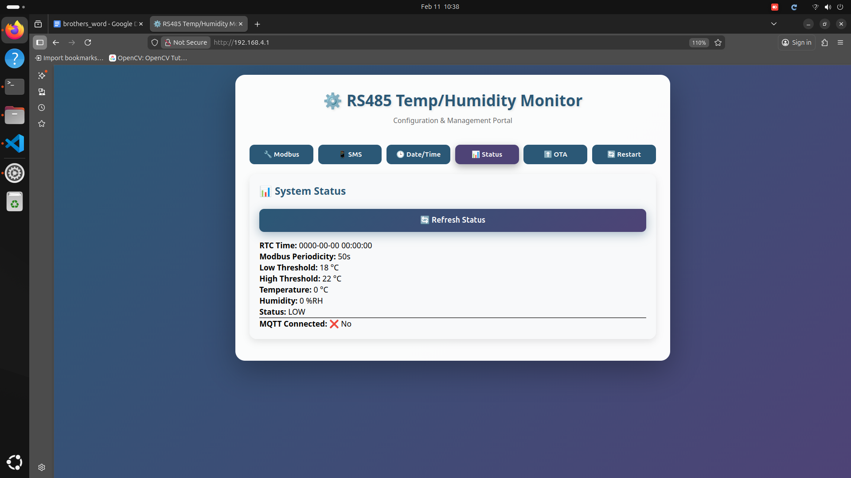

*Figure 3.4: System Status - Live temperature and humidity readings*

The status dashboard displays current environmental conditions and their status relative to configured thresholds. This is your primary monitoring interface for real-time data.

**Status Display Elements:**

* **Current Temperature:** Real-time temperature reading in degrees Celsius (°C) with large, easy-to-read display
* **Current Humidity:** Real-time relative humidity reading as a percentage (%RH)
* **Status Label:** Color-coded status indicator showing "NORMAL" (green), "HIGH" (red), or "LOW" (blue) based on threshold settings
* **Last Update Timestamp:** Shows when the sensor was last polled successfully
* **Sensor Communication Status:** Indicates if Modbus communication is working properly (CONNECTED/ERROR/TIMEOUT)

## 3.5 Firmware Update Interface

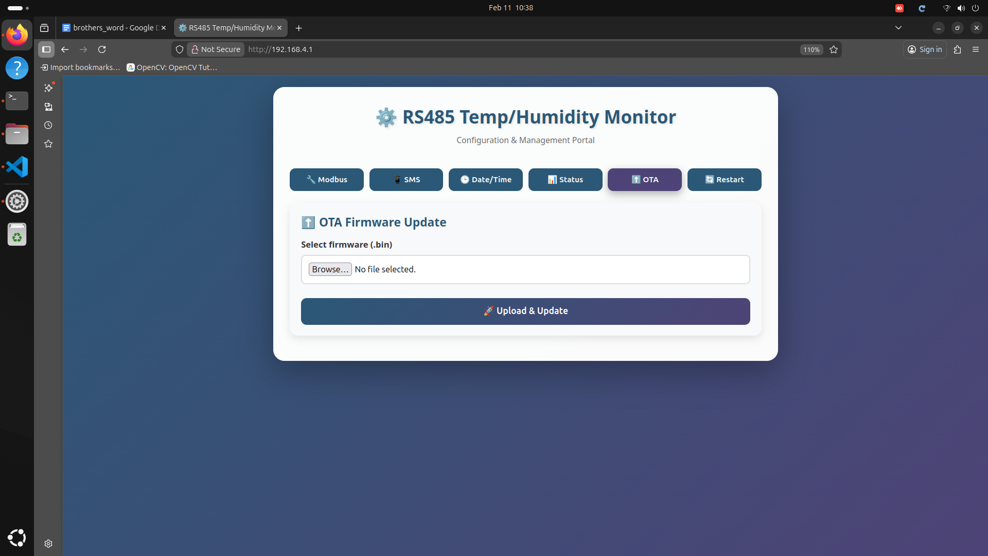

*Figure 3.5: OTA Update - Update Modbus communication stack and threshold logic*

This page allows wireless firmware updates to improve Modbus communication, add features, or enhance the threshold detection algorithms.

**Update Features:**

* **Firmware Upload:** Select and upload new .bin firmware files from your computer
* **Auto-Restart:** Device automatically reboots after successful firmware upload

## 3.6 System Restart and Maintenance

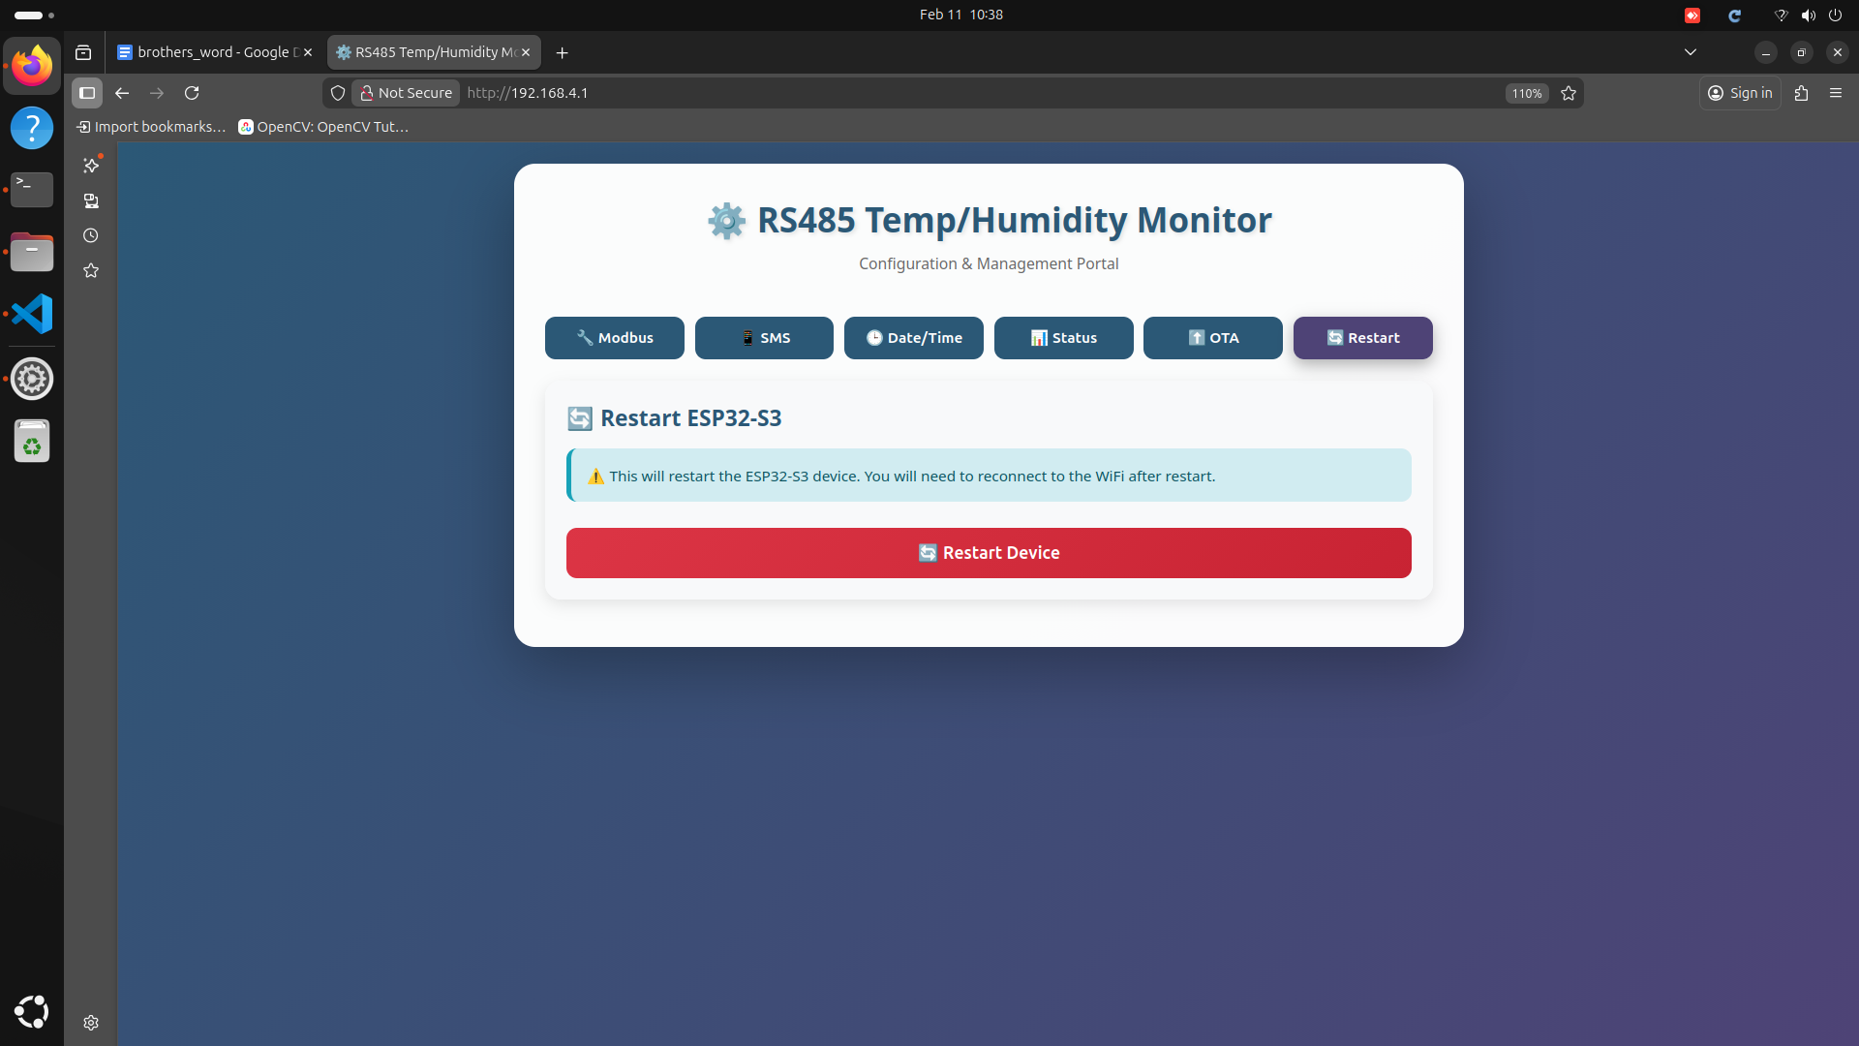

*Figure 3.6: Restart Page - Safe reboot with connection warning*

This page provides a safe way to reboot the ESP32-S3 hardware controller. Restarting can resolve communication errors, apply configuration changes, or clear temporary glitches.

**Restart Functionality:**

* **Soft Restart Button:** Performs a clean software reboot without cutting power to the sensor
* **Disconnection Warning:** The system alerts you that the SoftAP connection will be temporarily lost during reboot (typically 10-15 seconds)
* **Configuration Preservation:** All settings, thresholds, and contact numbers are saved in non-volatile memory and will persist after restart
* **Automatic Reconnection:** After reboot, the SoftAP network will broadcast again and you can reconnect using the same IP address (192.168.4.1)
* **System Health Check:** Upon restart, the system performs self-diagnostics to verify sensor communication, modem status, and configuration integrity

**💡 Best Practice:** *If you experience communication errors with the Modbus sensor, try restarting the system before checking physical wiring. Most communication issues are resolved by a simple restart.*

# Technical Support and Troubleshooting

This section provides common troubleshooting steps and support information for all three IoT projects.

## Common Issues and Solutions:

**Cannot Connect to SoftAP Network:**

* Ensure the device is powered on.
* Verify you are within Wi-Fi range (typically 3-4 meters depending on environment)
* Try restarting the ESP32 by power cycling the device
* Forget the network on your device and reconnect

**Portal Does Not Load:**

* Confirm you are using the exact IP address: 192.168.4.1
* Try using a different web browser (Chrome, Firefox, Safari)
* Clear your browser cache and cookies
* Disable VPN or proxy settings on your device

**SMS/Call Alerts Not Working:**

* Check the System Status page to verify the modem is registered on the cellular network
* Ensure the SIM card is properly inserted and activated
* Verify phone numbers are entered in the correct format (include country code if required)
* Check cellular signal strength on the status page (should be > -100 dBm)

**Fingerprint Sensor Not Responding (Project 2):**

* Ensure the sensor is properly connected to the pins
* Clean the sensor surface with a soft, lint-free cloth
* Check the Status page for sensor communication errors
* Try restarting the system from the System Control page

**Modbus Communication Errors (Project 3):**

* Verify RS485 wiring: A to A, B to B, and proper grounding
* Check that the sensor baud rate matches the ESP32 configuration (typically 9600 or 4800)
* Verify the Modbus address of the sensor matches the configuration

## Contact Information:

For technical support, firmware updates, or additional assistance, please contact:

**Phone:** 8553279301

**company:** Ampereplus Engineering and services.